Tank Game 2021 – Level Design
Background story/settings –
Tank Game is based on an old Atari game called Battlezone (released in 1980). It was considered one of the first successful FPS games and one of the first successful 3D games.
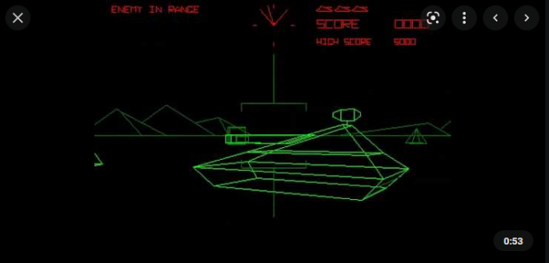
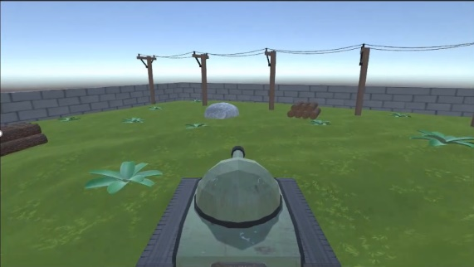
Tank Game takes inspiration from Battlezone and is a similar tank shooter game. Tank game however is a third person game with true 3D graphics in which the user fights against another player instead of an AI controlled enemy.
Game elements –
Scoring – The game is played until one player reaches the set score e.g. first to 3. At the end of each round the players will respawn in random positions to prevent one player for trapping the other in a spawn cycle.
Conflict – Players fight it out using a combination of aiming shots, timing shots, and tactical movement to try and land as many shots as they can whilst getting hit the least number of times.
Competition – PvP adds a level of competition as you want to beat your friend or whoever you are playing against and adds replay value to the game.
Strategy – The different levels of height in the terrain and the different types of cover can be used to gain an advantage over the other player to maximise your chances of success.
Art Style + Colour Palette –

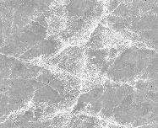

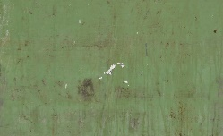
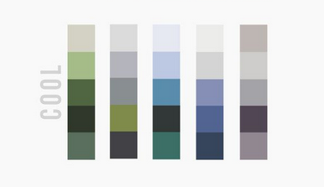
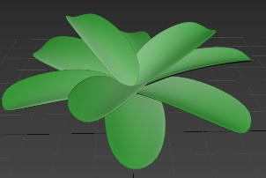
Tank game has arcade style graphics with textured models to add detail whilst keeping a cartoony feel to the game. The game uses a cool colour palette of soft colours - greens, greys, and browns (these colours are often associated with the military) to blend the graphics and colours into an art style that fits well with the games theme.

Focal point –
The focal point of the game is to eliminate your enemy before they eliminate you, because of this there is no level development. However, there are various maps you can play on to add variety to the gameplay. Each map keeps with the art style of the game whilst being unique enough to vary the gameplay and change up the players strategy depending on the map they are playing.
Tutorial level –
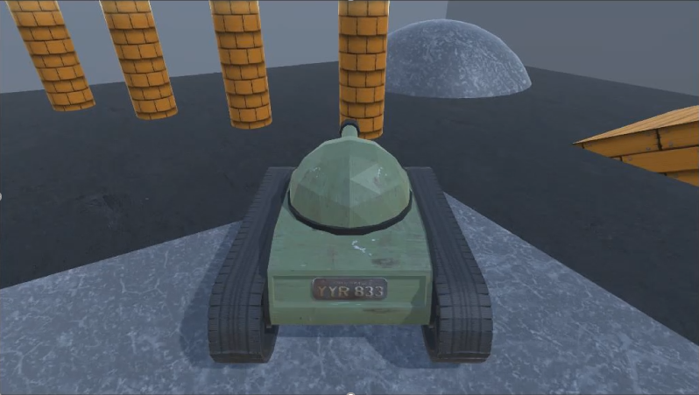
The tutorial level introduces the player to the controls that are used in Tank Game. The tutorial level has no enemies and contains various obstacles, ramps, and terrain to get the player used to the movement and mechanics of the game. The game objects are textured so the player isn’t stuck in a plain box with no texture to it but the detailing is minimal as the player will only spend a small amount of time on this level to get used to the game mechanics.
Map 1 –
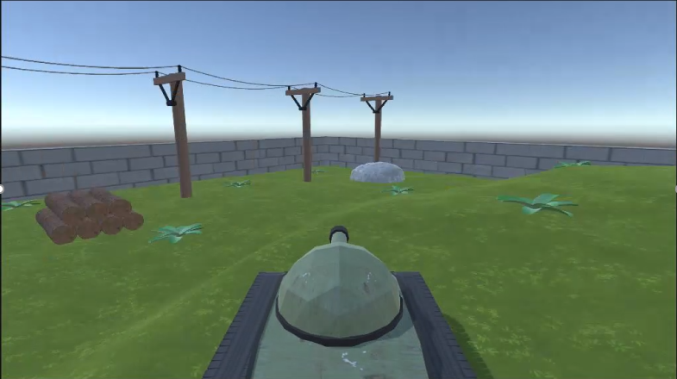
Map 1 is set in a field with varying degrees of elevation to the terrain to add some depth, so the map doesn’t feel as flat. At the bottom of the hill in the flattest area there are electricity pylons running from one side of the map to the other, they provide minimal cover for the player and are mainly included to add more detail to the map. The bushes are also there for detailing and depth to the map and provide no cover, unlike the pylons which you can bump into you can drive straight over the bushes. The cover the player can use are the round rocks and the log piles dotted around the map, this incorporates tactical movement and using the cover (and varying height) to your advantage to try and outplay the enemy and creates a further skill gap within the game.
Credits –
Background Music
https://www.bensound.com/royalty-free-music/track/the-duel

Tank Engine
https://www.zapsplat.com/music/infantry-tank-mark-ii-matilda-ii-engine-idles-external-rear-perspective/

Scripts
One of the other teachers (Paul) created the playercontroller and mouselooker scripts

